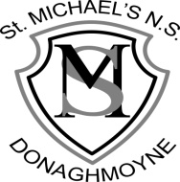

St Michael’s NS
Donaghmoyne Telephone: 042 9662284
Carrickmacross Email: donaghmoynens@eircom.net
Co. Monaghan Website: www.stmichaelsns.ie
A81 EA37

Principal: Ms F Whelan
Vice Principal: Mrs R Campbell

Notification regarding
St. Michael’s NS, Board of Management’s review
of the Child Safeguarding Statement

To: All School Personnel

The Board of Management of St. Michael’s NS wishes to inform you that:

• The Board of Management’s annual review of the school’s Child Safeguarding Statement was completed at the Board meeting of 19/3/19.

• This review was conducted in accordance with the “Checklist for Review of the Child Safeguarding Statement” published on the Department’s ‘website www.education.ie

Signed ______Patrick Boylan_______ Date __19/3/19_________

Chairperson, Board of Management

Signed ______Fiona Whelan________ Date ________________

Principal/Secretary to the Board of Management

