Additional Work to be Completed for Each Class –4th May-8th May 2020
- Some Activities are to be completed over a two week period (see dates).

English, Maths and Irish Activities (4th May-8th May 2020)
1st Class | 2nd Class | 3rd Class
English  English Reading –‘Two Little Frogs’-Read Story ‘Finn and the Giant’- (Reading - Please write in Page Numbers at front of book and Sign!)  - Complete written activities for ‘A Day on the Farm’). Don’t Worry about Colouring!  - Poem for May (Summer by Judy Bloomfield)-stick in copy and practice for each night and draw an accompanying picture  Maths  - Complete Week 30 in Mental Maths Book  - Mathemagic - Addition(revision) p105 –(Q2-Q4). This is what we have been doing in class. Complete all other questions using method below.  TU  1  27  +25  52  - Add the units to get 12. Are there any tens? Yes there is 1.  - Put the ten over with the tens (red) and circle it.  - Leave the 2 units with the units.  - Now add the tens -5  - Answer 52.  Irish  - Abair Liom C – Aonad 26 – Ar Saoire  - Continue to:  - Revise Vocabulary - pages 130-131 – Go through Vocabulary. Click on the Link to play games to practice the vocabulary 1 and 2.  - P133- Listen to the comhrá/conversation online – Click on the Link and practice it with someone at home.  - P134-put the correct clothes names in the boxes for either a hot or cold day  - Watch some Cúla-TG4 | English  - English–‘The Green Genie’-Reading Completed. Complete Written Activities for ‘Tigers’ p93-p95.  - English Reading – The Ladybird p58 Treasury B Read Story  - Poem for May (Summer by Judy Bloomfield)-stick in copy and practice for each night and draw an accompanying picture  Maths  - Complete Week 30 in Mental Maths Book  - Mathemagic - Length p101 (Question 1- (measure lines only and write answers in copy e.g. a=3cm etc.-Don’t do grid). (Question 3 – draw line correct length and write measurement under the line). Complete in maths copy please  Irish  - Abair Liom D – Aonad 22 – An Luascán Nua –The New Swing  - Continue to:  - Revise Vocabulary - pages 106-107 – Go through Vocabulary. Click on the Link to play games to practice the vocabulary 1 and 2.  - p110-Write word under pictures and complete wordsearch.  - Practice Reading Sheet for May  - Watch some Cúla-TG4 | English  - English Reading - The First Lighthouse p52-p53 Treasury C –Read Story and complete activity A and B in your copy  - Poem for May (Summer by Judy Bloomfield)-stick in copy and practice for each night and draw an accompanying picture  Maths  - Complete Week 30 in Mental Maths Book  - Mathemagic - Length p67- (Question 2 and 3)  - Look at the pictures. You don’t need to draw anything.  - Just estimate and measure in Q2 and Measure in Q3-don’t forget to write cm (for centimetre).  - When using your ruler always place 0cm at beginning of the line!  Irish  - Abair Liom D – Aonad 17 – Lá sa Pháirc  - Continue to:  - Revise Vocalulary - pages 140-141– Go through Vocabulary. Click on the Link to play games to practice the vocabulary.  - P143- Listen to the comhrá/  conversation online – Click on the Link and practice it with someone at home.  - Complete Sentences - p145(f-fill in the blanks-pick the correct part of the past tense from the purple boxes – e.g. 1. Chonaic mé Mamaí agus Síofra ag imirt leadóige.) At bottom of page- pick correct part of the verb to fill in the spaces (e.g 2 = Ní fhaca mé an moncaí-because no moncaí in picture).  - Practice Reading Sheet for May  - Watch some Cúla-TG4
- 4th May-15th May 2020 (Complete Over 2 Weeks)
- S.P.H.E. – (Myself and the Wider World-Developing Citizenship)
- Role of Local Clubs-
- Discuss local clubs and the role they have(supporting others, setting goals and targets, recognising the strengths of others, adhering to democratic rules and regulations, respecting the views of everyone).
- Discuss the importance of rules in order for a club to be able to succeed. If you could form a club, what would it be and what would be the main rules put in place in order for the club to be a success.
- Design a rules poster for a club name of you own design/choice, taking into account what you have discussed.(In Hardback Copy)

- 4th May-15th May 2020 (Complete Over 2 Weeks)
S.E.S.E. – (Science-Materials-Properties and Characteristics of Materials)-Do this in Your Hardback Copy!
- Look back at the list of material types you listed.
- Can you remember two describing words for each of them?
- Look at the word ABSORBANT. Do you know what it means? Find out what it means and write a definition for it in your hardback. Absorbent =…….
- What do you thing water-resistant means? Find out and do the same for this word. Water-Resistant =…..
- Find these items (something wooden (e.g. a ruler), something plastic (e.g. a cup), something metal (e.g. a toy car/a spoon), something cloth/material, tissue, kitchen roll.
- Look at, feel and guess if you think each object is Absorbent or Water-Resistant, before testing in a bowl/basin of water.
- Complete the chart in your hardback.
Material | Object made from this Material | Absorbent/Water Resistant.
- Divide a page in two and draw and label 4 objects that are Absorbent and 4 that are water-resistant.
Absorbant | Water-Resistant

- Religion – 4th May-15th May 2020 (Complete Over 2 Weeks)
- Say a morning prayer and evening prayer each day and night.
- Say a ‘Hail Mary’ once a day.
- Discuss the Month of May. What season is it in? May is the month in which we honour Mary. Discuss what we think of when we think of Mary. In your religion copy complete a page as follows….

Mary
In May I think of Mary. When I think of Mary I think of…….
- Draw a picture of yourself in the centre of your page.
- Draw four different thought bubbles around yourself.
- In each one write, something you think of when you think of Mary.

- Art – Materials 4th May-15th May 2020 (Complete Over 2 Weeks)
- Draw a large picture of yourself.
- Design and create an outfit for you to wear in summer.
- Use different materials (e.g cloth, tinfoil, tissue, paper, buttons, cotton wool) to make yourself look summer ready!

- Music– 4th May-15th May 2020 (Complete Over 2 Weeks)
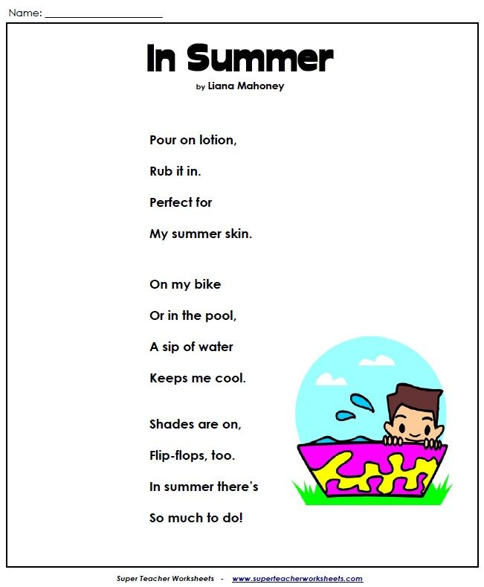
- Read the poem a few times
- Imagine the sounds you would hear (e.g. the sound of lotion squirting out..)
- Make the poem into a rap, using objects, your body, or your voice create accompanying sounds for your rap.
- Add some actions too.
- Perform for your family and make a recording to show to other family members or friends.
- P.E.– 4th May-15th May 2020 (Complete Over 2 Weeks)
- Dance
- Pick a song each week from Just Dance (Youtube) and perfect the moves to go along with it.
- Try doing some exercise with Joe Wicks (The Body Coach) on Youtube.

- Alvin Ailey- Choreographer “Revelations” -
- Google images by Alvin Ailey from Revelations will be used for this activity (see below).
- Perform each pose individually to music of your choice hold for the count of five.
- Come out of the pose and stand upright and go back into the pose and repeat.
- Combine all the poses, holding for five before progressing to the next pose.
- Can you alternate between poses to create a dance for your entire song?
