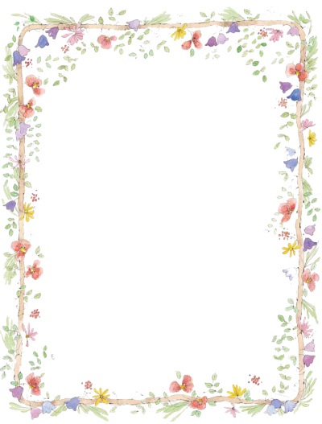
Wellness Wednesday

You are working really hard, this your teachers know,
Time for something fun to do, pick one and have a go!
Each Wednesday, of every week, school books will stay away,
It’s time to bake, or read or build or simply stop and play.

- Go on a nature walk around your house - what can you find?
- Learn a new Dance
- Play football or practice your football skills
- Watch a movie (if it is raining)
- Re-design an old t-shirt
- Play a board game
- Read a book
- Create an exercise circuit in your garden
- Make a paper plane
- Build a tower using what is in the recycling bin
- Build a bridge using spaghetti and pasta
- Paint a picture
- Have a talent show
- Learn a song
- Make an obstacle course in your garden
- Create a new outdoor game
- Bake something nice
- Draw something
- Play hide and seek
- Colour
- Write a letter to a friend
- Practice some gymnastics - rolling, jumping

