Additional Work to be Completed for Each Class –11th May-15th May 2020
- Some Activities are to be completed over a two week period (see dates).

English, Maths and Irish Activities (11th May-15th May 2020)
1st Class | 2nd Class | 3rd Class
English  English Reading –‘Two Little Frogs’-Read Stories ‘Night and Day’ and 'Sun, Moon and Stars, one story every two nights (Mon-Tues, Wed-Thurs)( Reading - Please write in Page Numbers at front of book and Sign!)  - Complete written activities for ‘The Ant and the Grasshopper’ and 'Finn and the Giant). Don’t Worry about Colouring!  - Poem for May (Summer by Judy Bloomfield)-continue to practice poem each night.  Maths  - Complete Week 31 in Mental Maths Book  - Mathemagic - Addition(revision) p120-p121 .This is what we have been doing in class. Complete all other questions using method below.  TU  13  +15  28  - Add the units to  - get 8.  - Are there any tens here? NO. So we don’t need to put any tens with the tens.  - Now add the tens side=2.  - Answer 28.  - *use last weeks method if you have tens when your units are added.  Irish  - Abair Liom C – Aonad 26 – Ar Saoire  - Continue to:  - Revise Vocabulary - pages 130-131 – Go through Vocabulary. Click on the Link to play games to practice the vocabulary 1 and 2.  - P133- Listen to the comhrá/conversation online – Click on the Link and practice it with someone at home.  - P135-pick the correct sound i or í(an e sound) and complete the wordsearch.  - Watch some Cúla-TG4 | English  - English–‘The Green Genie’-Reading Completed and All Written Activities Completed.  - English Reading – The Ladybird p58 Treasury B Read Story and Complete activities (a and b) in your English copy.  - Poem for May (Summer by Judy Bloomfield)- continue to practice poem each night.  - Maths  - Complete Week 31 in Mental Maths Book  - Mathemagic - Length p102- (You don’t need to write the questions, just the answers). P103(Do all sums out, showing your work as follows:  TU  23  + 16  39cm –remember to add units first and then the tens.  - Complete work in maths copy please!  Irish  - Abair Liom D – Aonad 22 – An Luascán Nua –The New Swing  - Continue to:  - Revise Vocabulary - pages 106-107 – Go through Vocabulary. Click on the Link to play games to practice the vocabulary 1 and 2.  - p111-pick the correct sound 'a' or 'o' to complete the words.  - Practice Reading Sheet for May  - Watch some Cúla-TG4 | English  - English Reading - The Salmon of Knowledge p82 Treasury C –Read Story and Complete activities (a and b) in your English copy.  - Poem for May (Summer by Judy Bloomfield)- continue to practice poem each night.  Maths  - Complete Week 31 in Mental Maths Book  - Mathemagic - Length  - p68- (Question 1 and 2-write sums into your copy, exactly as they are in the book)  - 1 metre can be written as 1m for short!  - Centimetre is written as cm for short!  - If you have a measuring tape, identify 1m is the same as 100cm  - p69- (Question 1, 2 and 3)  - SEE EMAIL I SENT FOR METHOD-ANY QUESTIONS GET IN TOUCH!  Irish  - Abair Liom D – Aonad 17 – Lá sa Pháirc  - Continue to:  - Revise Vocalulary - pages 140-141– Go through Vocabulary. Click on the Link to play games to practice the vocabulary.  - P143- Listen to the comhrá/  - conversation online – Click on the Link and practice it with someone at home.  - p146-Click on the Link and enter your details to complete the listening activity/listen to the voice recording I have sent to your email. Complete sentences using 'as bheith ag' and pick correct hobby.  - p147-J - fill in 'ái' sound-sound = 'aw and try to read the words you have made.  - Practice Reading Sheet for May  - Watch some Cúla-TG4
- 4th May-15th May 2020 (Complete Over 2 Weeks)
- S.P.H.E. – (Myself and the Wider World-Developing Citizenship)
- Role of Local Clubs-
- Discuss local clubs and the role they have(supporting others, setting goals and targets, recognising the strengths of others, adhering to democratic rules and regulations, respecting the views of everyone).
- Discuss the importance of rules in order for a club to be able to succeed. If you could form a club, what would it be and what would be the main rules put in place in order for the club to be a success.
- Design a rules poster for a club name of you own design/choice, taking into account what you have discussed.(In Hardback Copy)

- 4th May-15th May 2020 (Complete Over 2 Weeks)
S.E.S.E. – (Science-Materials-Properties and Characteristics of Materials)-Do this in Your Hardback Copy!
- Look back at the list of material types you listed.
- Can you remember two describing words for each of them?
- Look at the word ABSORBANT. Do you know what it means? Find out what it means and write a definition for it in your hardback. Absorbent =…….
- What do you thing water-resistant means? Find out and do the same for this word. Water-Resistant =…..
- Find these items (something wooden (e.g. a ruler), something plastic (e.g. a cup), something metal (e.g. a toy car/a spoon), something cloth/material, tissue, kitchen roll.
- Look at, feel and guess if you think each object is Absorbent or Water-Resistant, before testing in a bowl/basin of water.
- Complete the chart in your hardback.
Material | Object made from this Material | Absorbent/Water Resistant.
- Divide a page in two and draw and label 4 objects that are Absorbent and 4 that are water-resistant.
Absorbant | Water-Resistant

- Religion – 4th May-15th May 2020 (Complete Over 2 Weeks)
- Say a morning prayer and evening prayer each day and night.
- Say a ‘Hail Mary’ once a day.
- Discuss the Month of May. What season is it in? May is the month in which we honour Mary. Discuss what we think of when we think of Mary. In your religion copy complete a page as follows….

Mary
In May I think of Mary. When I think of Mary I think of…….
- Draw a picture of yourself in the centre of your page.
- Draw four different thought bubbles around yourself.
- In each one write, something you think of when you think of Mary.

- Art – Materials 4th May-15th May 2020 (Complete Over 2 Weeks)
- Draw a large picture of yourself.
- Design and create an outfit for you to wear in summer.
- Use different materials (e.g cloth, tinfoil, tissue, paper, buttons, cotton wool) to make yourself look summer ready!

- Music– 4th May-15th May 2020 (Complete Over 2 Weeks)
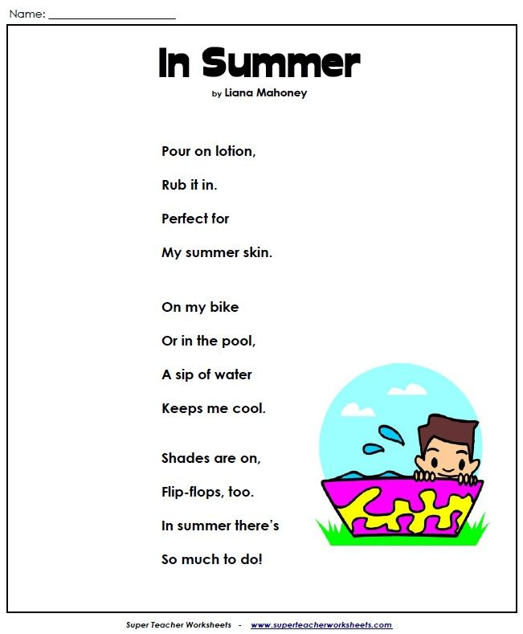
- Read the poem a few times
- Imagine the sounds you would hear (e.g. the sound of lotion squirting out..)
- Make the poem into a rap, using objects, your body, or your voice create accompanying sounds for your rap.
- Add some actions too.
- Perform for your family and make a recording to show to other family members or friends.
- P.E.– 4th May-15th May 2020 (Complete Over 2 Weeks)
- Dance
- Pick a song each week from Just Dance(youtube) and perfect the moves to go along with it.
- Try doing some exercise with Joe Wicks (The Body Coach) on Youtube.

- Alvin Ailey- Choreographer “Revelations” -
- Google images by Alvin Ailey from Revelations will be used for this activity (see below).
- Perform each pose individually to music of your choice hold for the count of five.
- Come out of the pose and stand upright and go back into the pose and repeat.
- Combine all the poses, holding for five before progressing to the next pose.
- Can you alternate between poses to create a dance for your entire song?
