Additional Work to be Completed for Each Class –1st June-5th June 2020
(English, Irish and Maths)
- Some Activities are to be completed over a two week period (see dates).

English, Maths and Irish Activities (1st-5th June 2020)
1st Class | 2nd Class | 3rd Class
English  English Reading –‘Two Little Frogs’-Read Stories ‘The Colours of the Rainbow’ and Rapunzel’, one story every two nights (Mon-Tues, Wed-Thurs)( Reading - Please write in Page Numbers at front of book and Sign!)  - Complete written activities for ‘Jack and his Cat' and 'The Cat Family'). Don’t Worry about Colouring!  - Poem for June 'Sand by John Foster'-Stick Poem into Copy and Practice for Each Night. Do a picture to accompany your Poem.  Maths  - Complete Week 34 in Mental Maths Book  - Mathemagic -  - Please revise below!  - Time (1st Class) - On a clock,the minute hand is longer than the hour hand. When the minute hand is at 12,it is something o' clock. The shorter hour hand tells us which o' clock it is. If you have a clock at home - practice showing different o'clock times, by moving the hands to the correct position.  - Half Past - When a clock shows half past the longer minute hand is at six. The shorter hour hand tells which half past it is. The hour hand will be half way past the number of the time shown. (e.g if it is half way past the nine - it is half past nine. Also practice showing half past times on a clock!  - Days of the Week-Time can also be counted in days. Can you say the days of the week? Practice naming the first, second, third ....last day of the week. What days are at the weekend? What do you do on certain days? Complete p20  - Ordering Time  Events happen in a certain order-Something happens first, next and last.  Complete p21-ordering events in the correct order., P22 add in the missing part of the story/event.  - Time, Year,Months, Seasons  - Discuss a year having four seasons. Name them. How many months in each season? Name them. How many seasons in a year? How many months in a year? Name the first month, the second month......, the last month.  - Complete p23  Irish  - Abair Liom C – Aonad 25 – Ag Pacáil  - p124-p125- Click on the Link on website to practice the vocabulary.  P126-Put the correct item into the suitcase.  Culaith Shnámha=Swimsuit  - p127- Listen to voice recorded message sent by email to complete this activity.  - p128-Fíor=true/Bréagach=  - false-write the correct word in the space. Taos Fiacla=Toothpaste  - p129-Listen to voice recorded message sent by email to complete this activity.  - Watch some Cúla-TG4 | - English Reading – Who Can Jump Highest p46 Treasury B Read Story and Complete activities (a, b and c) in your English copy.  - Poem for June 'Sand by John Foster'-Stick Poem into Copy and Practice for Each Night. Do a picture to accompany your Poem.  Maths  - Complete Week 34 in Mental Maths Book  Mathemagic -  - Time (2nd Class) - On a clock,the minute hand is longer than the hour hand. When the minute hand is at 12,it is something o' clock. The shorter hour hand tells us which o' clock it is. If you have a clock at home - practice showing different o'clock times, by moving the hands to the correct position.  - Half Past - When a clock shows half past the longer minute hand is at six. The shorter hour hand tells which half past it is. The hour hand will be half way past the number of the time shown. (e.g if it is half way past the nine - it is half past nine. Also practice showing half past times on a clock!  - Quarter Past - When a clock shows a quarter past the longer minute hand is at three. The shorter hour hand tells which a quarter past it is. The hour hand will be a quarter way past the number of the time shown. (e.g if it is a quarter way past the nine - it is a quarter past nine. Also practice showing a quarter past times on a clock!  - Quarter To - When a clock shows a quarter to the longer minute hand is at nine. The shorter hour hand tells which a quarter to it is. The hour hand will be a quarter away from the number of the time shown. (e.g if it is a quarter away from the nine - it is a quarter to nine. Also practice showing a quarter to times on a clock!  - p106-complete activities (Q1-Q2) in copy-write answers-don't draw clocks. 2. 4:30=half past 4 etc.  - p107-(Q1-Q3) in copy-write answers-don't draw clocks.  - p108-(Q1-Q3) in copy-write answers-don't draw clocks.  Irish  - Abair Liom D – Aonad 25 – Lá ar an Trá  - 124-125- Click on the Link on website to practice the vocabulary.  - p126-Practice the Ról Imirt /Conversation with a partner by listening to the voice recording sent via email.  - p127-fill in the missing answers by picking the correct item of clothing.  - p128- Complete (c) by listening to voice recording sent via email. (D)-Fíor =True/Bréagach=False, tick or x appropriately.  - p129- fill ea into the spaces to complete the words and complete the wordsearch.  - Practice Reading Sheet for June  - Watch some Cúla-TG4 | - English Reading – The Miller and the Donkey p88 Treasury C –Read Story and Complete activities (a, b and c) in your English copy.  - Poem for June 'Sand by John Foster'-Stick Poem into Copy and Practice for Each Night. Do a picture to accompany your Poem.  Maths  - Complete Week 34 in Mental Maths Book  Mathemagic -  - Time (3rd Class) - On a clock,the minute hand is longer than the hour hand. When the minute hand is at 12,it is something o' clock. The shorter hour hand tells us which o' clock it is. If you have a clock at home - practice showing different o'clock times, by moving the hands to the correct position.  - Half Past - When a clock shows half past the longer minute hand is at six. The shorter hour hand tells which half past it is. The hour hand will be half way past the number of the time shown. (e.g if it is half way past the nine - it is half past nine. Also practice showing half past times on a clock!  - Quarter Past - When a clock shows a quarter past the longer minute hand is at three. The shorter hour hand tells which a quarter past it is. The hour hand will be a quarter way past the number of the time shown. (e.g if it is a quarter way past the nine - it is a quarter past nine. Also practice showing a quarter past times on a clock!  - Quarter To - When a clock shows a quarter to the longer minute hand is at nine. The shorter hour hand tells which a quarter to it is. The hour hand will be a quarter away from the number of the time shown. (e.g if it is a quarter away from the nine - it is a quarter to nine. Also practice showing a quarter to times on a clock!  - p83-complete activities (Q1-Q2) in copy-write answers-don't draw clocks.  - Get a clock if possible. Each number on the clock represents five minutes. The righthand side of the clock is the past side and left is the to side!  - Count from 1-6 in fives -on the right hand(past)side- 5/10/15/20/25/30 minutes past -Remember 15 minutes past is a quarter past and 30 minutes past is half past.  - On the left hand side start at seven and count from 25 backwards in fives. (25 to/twenty to etc).  - When the minute hand is on twelve it is ...o' clock.  - p84 -write answers-don't draw clocks.  - p85-write answers-don't draw clocks.  Irish  - Abair Liom D – Aonad 12 - An Sorcas  - p102-(Answer questions (g) with either Chonaic mé=I saw/Ní fhaca mé=I didn't see e.g 1=Chonaic mé Mamaí sa siopa éadaí. Tick the correct box at the bottom and fill in the spaces in 3-5 as in 1-2.  - p103 -Pick the correct form of ar (orm/ort/air/uirthi for the correct person)e.g 1=Chuir mé mo chóta orm mar bhí mé fuar. orm=on me(mé). Use io and é to complete the words.  - p104-p105 -Use the help words to label the characters and complete the story in K using help words and story M using the exact same format.  - Practice Reading Sheet for June  - Watch some Cúla-TG4
- 1st June-12th June 2020 (Complete Over 2 Weeks)
- S.P.H.E. – (Safety and Protection - Personal Safety)
Water Safety
- Click on Link www.teachpaws.ie and this will bring you to the Irish Water Safety Website.
- Scroll down and click on this image.
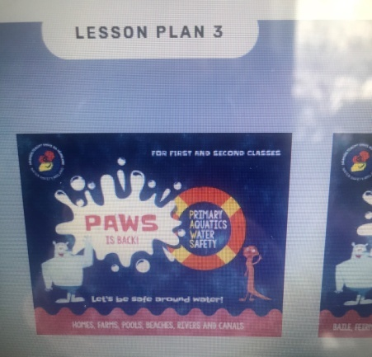 - Water Safety Booklet
- Read the Water Safety Booklet aloud.
- After reading each page, see can you recall two safety tips for each one.
- Go back to the home page or reuse the link above and click on the image that looks like the picture below….

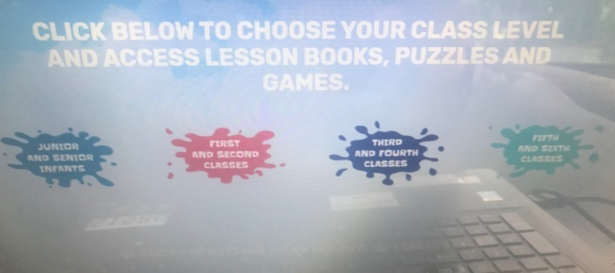-
CLICK ON RED (First and Second Class)
- Click on each Life Buoy and Complete the online activities surrounding water safety (What’s the Word?, Say it Right!, Yes or No!, Click the Correct Picture, Does this Float?, Is it Safe?, Finish the Word).
- In your hardback write the title ‘Water Safety Tips' and write down 5 water safety tips and illustrate them. Divide your page as shown below.
- Design a poster with a slogan to show one of your safety tips.
Water Safety Tips
1. | 2.
3. | 4.
5.

- 1st June-12th June 2020 (Complete Over 2 Weeks)
Geography – (Human Environments -My County)- Copy or print the templates and do in your Hardback Copy!
- Before you commence this activity, get a piece of paper and brainstorm as many things as you can that you already know about your County.
- Then click on the link below and complete the templates and put them into your hardback copy. Alternatively copy the information from the templates into your copy in order to complete them-if no printer is available.

Click on the PDF File to View the Templates

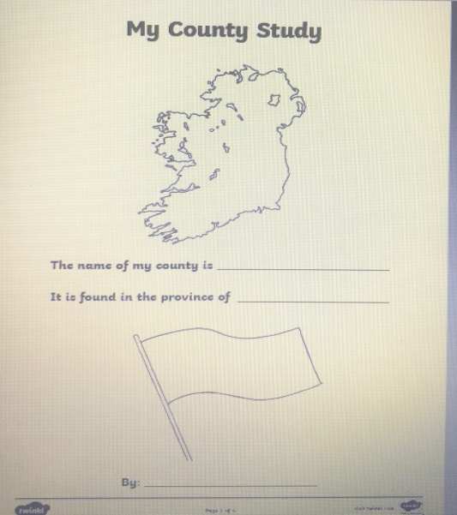Template 1

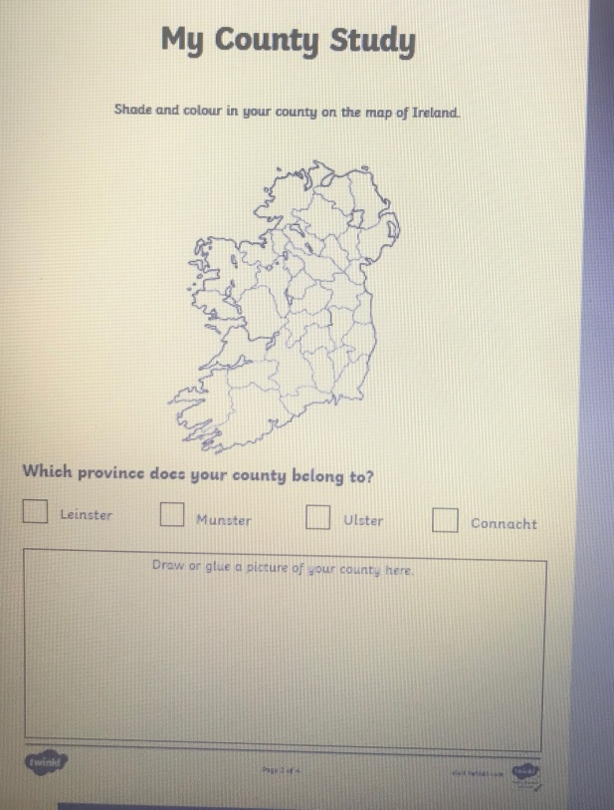 Template 2

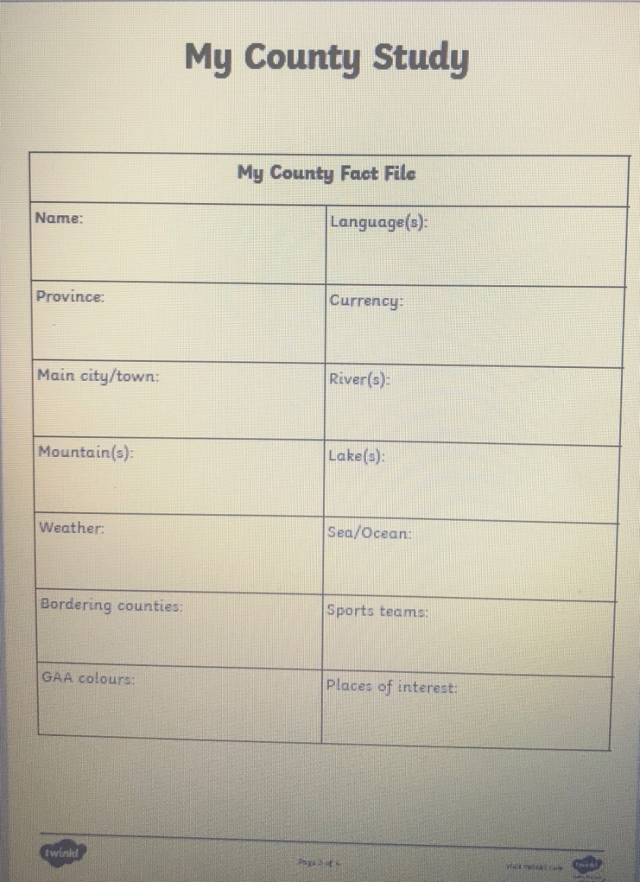Template 3

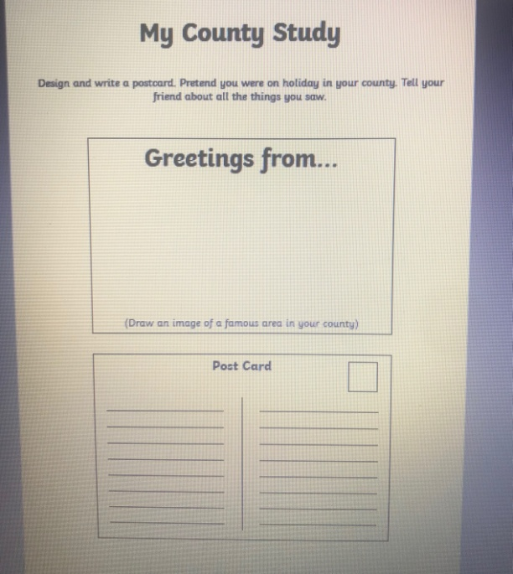Template 4

- Religion – 1st June-12th June 2020 (Complete Over 2 Weeks)
- Say a morning prayer and evening prayer each day and night.
The Importance of Water in the Church.

- What do you call the special water that is used in the church? It is known as Holy water and it is water that has been blessed by a member of the clergy for example, a priest.
- Holy Water is used in the church for many reasons and occasions.
- Every time we bless ourselves with Holy water, we are reminded of the Holy water poured on our heads at our Baptism (when we were welcomed into God's family).
- Holy water cleanses away our sins and also protects us.
- Talk about and research other times we use Holy water in the church. Complete a page in your religion copy as follows and illustrate your examples.
Water is Important in the Church
Holy water is used at....... | Holy water is used at.......
Holy water is used at....... | Holy water is used at.......
*Practice blessing yourself with Holy water and say your favourite prayer.

- Art – Paint and Colour, Construction -1st June-12th June 2020 (Complete Over 2 Weeks)
Under the Sea.
- Discuss things you think you might find under the sea. What type of creatures, plants, objects may you see there? They can be real or imaginary!
- You can paint/construct/or both what you imagine you would find under the sea.
- Here are some pictures for inspiration but use your imagination to create your Under the Sea themed art.
- Send me a picture of your art work.
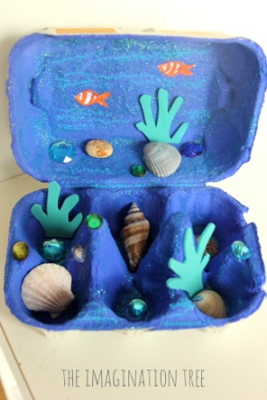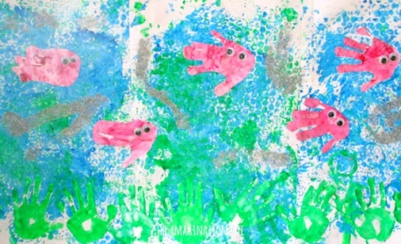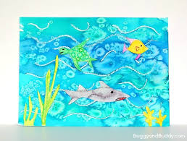

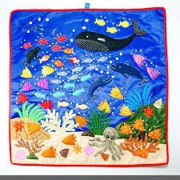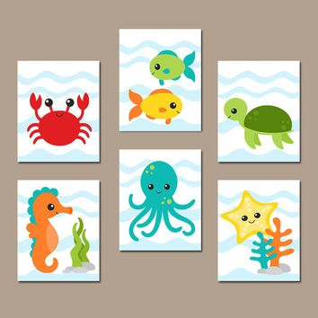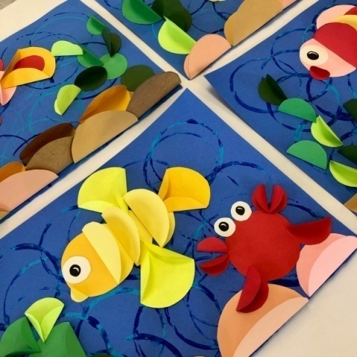

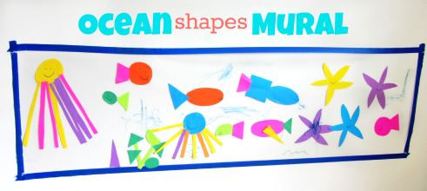

- Music (Listening and Responding, Performing)– 1st June-12th June 2020 (Complete Over 2 Weeks)
- Rock the Boat. This is one for all the family! Watch the video and try out the 'Rock the Boat Song.
- https://www.youtube.com/watch?v=Kq00G0T-JQw.
- Challenge - use other modes of transport in the song in place of a boat - for example, Rock the Bicycle, Rock the Car, Rock the Skateboard and imagine doing the actions for moving this mode of transport.
- Continue to practice a tune a day on your tin whistle.
- P.E.– 1st June-12th June 2020 (Complete Over 2 Weeks)

- Gymnastics
- Move into free space using various travelling movements (walk, hop, skip, jump). Move forwards, backwards and side wards, using these movements. Explore different pathways (straight, curved and zigzag). Explore different speeds and heights (e.g. walk high (e.g. high knees and arms, and low feet and arms).
- Explore different ways of travelling on their feet (hopping, skipping, marching, twirling). Change the speed and the height of the movements.
- Travelling on hands and feet, explore different ways of travelling on these body parts, forwards and backwards. Can you do it with tummy facing, facing away from the ceiling. Create a sequence. Travel on two hands and two feet, one and and two feet and vice versa.
- Balancing on large body parts(bottom, front, side, back and shoulders). Holding each balance for a count of 3. Can you move from one balance to another and hold for 3?
- Balancing on small body parts, one hand, one foot, two hands, one foot, two knees and one hand, two hands and two feet, two knees and two elbows. Holding each balance for a count of 3. Can you move from one balance to another and hold for 3?
- Jumping –basic jumps -2 feet to 2 feet, 2 feet to one foot, 1 foot and hop to other foot, 1 foot to two feet (jump), create sequence of jumps. How many jumps does it take you to travel a set distance?

- Pick a song each week from Just Dance (Youtube) and perfect the moves to go along with it.
- Try doing some exercise with Joe Wicks (The Body Coach) on Youtube.
- Continue with Wellness Wednesday Activities.

