Additional Work to be Completed for Each Class –25th May-29th May 2020
- Some Activities are to be completed over a two week period (see dates).

English, Maths and Irish Activities (25th May-29th May 2020)
1st Class | 2nd Class | 3rd Class
English  English Reading –‘Two Little Frogs’-Read Stories ‘Jack and his Cat’ and 'The Cat Family’, one story every two nights (Mon-Tues, Wed-Thurs)( Reading - Please write in Page Numbers at front of book and Sign!)  - Complete written activities for ‘The Fox and the Chicken' and The Man Who Tried to Please Everyone'). Don’t Worry about Colouring!  - Poem for May (Summer by Judy Bloomfield)- continue to practice poem each night.  Maths  - Complete Week 33 in Mental Maths Book  - Mathemagic -  Weight (1st Class) - On a scales the heavier object is the one that goes down furthest. The lighter object will be higher. If two objects are the same height, we say that they are the same weight or that they are balanced.  - p106 - Complete the weight activities based on the pictogram.  - p107-Complete Question 1 and Question 2, by looking at the pictures.  - Practical Activity - Look around your kitchen. Can you find 4 items that weigh 1kg (kilogram)? If possible find 4 items lighter than 1kg and 4 items heavier than 1kg. If you have a scales to demonstrate this - try it out!  - Time (1st Class) - On a clock,the minute hand is longer than the hour hand. When the minute hand is at 12,it is something o' clock. The shorter hour hand tells us which o' clock it is. If you have a clock at home - practice showing different o'clock times, by moving the hands to the correct position.  - p92-write the correct time on the clocks.  - Half Past - When a clock shows half past the longer minute hand is at six. The shorter hour hand tells which half past it is. The hour hand will be half way past the number of the time shown. (e.g if it is half way past the nine - it is half past nine.  - p93-write the correct time on the clocks.  - p94-draw hands on the clocks to show the times. Remember the minute hand is longer than the hour hand!  Irish  - Abair Liom C – Aonad 4 – An Linn Snámha  - p22-23- Click on the Link on website to practice the vocabulary.  - p24-Cé atá ag snámh?=Who is swimming?  Tá Mamaí ag snámh=Mammy is swimming. Practice asking and answering the questions and complete the activities as shown.  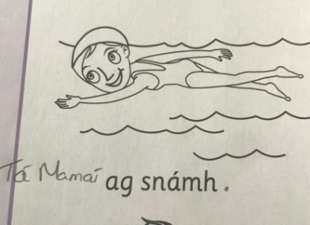  - p25-(c)-read and match the sentence.  - p26-Tá áthas orm =I am happy. Tá eagla orm=I am frightened. Tá fearg orm=I am angry. Tick if true(fíor)/x if false(bréagach).  - p27-Listen to voice recorded message sent by email to complete this activity.  - Watch some Cúla-TG4 | - English Reading – The Little White Cat p70 Treasury B Read Story and Complete activities (a, b and c) in your English copy.  - Poem for May (Summer by Judy Bloomfield)- continue to practice poem each night.  Maths  - Complete Week 33 in Mental Maths Book  Mathemagic -  - Time (2nd Class) - On a clock,the minute hand is longer than the hour hand. When the minute hand is at 12,it is something o' clock. The shorter hour hand tells us which o' clock it is. If you have a clock at home - practice showing different o'clock times, by moving the hands to the correct position.  - p40-complete activities based on the calendar- write the answers only-you don't need to write full sentences.  - p41-write the missing words in your copy you don't need to write full sentences.  - p59- answer the questions based on the time-table- you don't need to write full sentences.  - p105-write and draw the correct times on the clocks.  Irish  - Abair Liom D – Aonad 2 – Picnic  - p10-11- Click on the Link on website to practice the vocabulary.  - p12-Practice the Ról Imirt /Conversation with a partner by listening to the voice recording sent via email.  - p13-fill in the missing answers.  - p14- Complete (c) by listening to voice recording sent via email.  - p15- Complete (E) by listening to voice recording sent via email.  - Practice Reading Sheet for May  - Watch some Cúla-TG4 | - English Reading – The Fairies p70 Treasury C –Read Story and Complete activities (a, b and c) in your English copy.  - Poem for May (Summer by Judy Bloomfield)- continue to practice poem each night.  Maths  - Complete Week 33 in Mental Maths Book  Mathemagic -  - Weight - kg (kilogram),  g(gram).  - p157 (Complete all questions in your copy) -For all questions -you should calculate in your head and write only the answers as follows.  - 1(a). 6g  1(b). 12g  - p160-Adding and Subtracting kg and g.  - Complete All Questions as follows. -Similar to procedure for Length!  1(d)  kg 1 g  1 580  +2 190  3kg 770g  -ADD G(grams) FIRST AND PUT NUMBER IN RED IN A CIRCLE  -THEN ADD THE KG(kilograms)  -See procedure below for Subtraction Method.  -Remember to only swap only if the number on the top is smaller than the number on the bottom and you cannot take away!  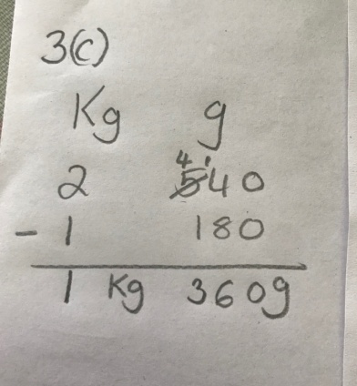  Irish  - Abair Liom D – Aonad 12 - An Sorcas  - p98- Use the voice recording sent via email to practice reading the story.  - p99(a)-answer the questions using the story on p98, (b) Draw a picture of what you think happened next and try to write one sentence about your picture.  - p100 (c) -Pick the correct feeling word from the selection. (luiteoga nua =new leggings, tintreach=lightning, ar strae=lost, cúl=goal, a mhilseáin=his sweets). (d)-Go Tobann = suddenly, Bunoscionn=upside down/a mess. Pick one to fill in the gaps.  - p101- (e)-Use the voice recording sent via email to practice the conversation. (F)-Try to fill in the spaces to explain what the characters are wearing. (hata=hat, riteoga=tights, gúna=dress, bróga=shoes, léine=shirt, seaicéad fada=long jacket).  - Practice Reading Sheet for May  - Watch some Cúla-TG4
- 18th May-29th May 2020 (Complete Over 2 Weeks)
- S.P.H.E. – (Safety and Protection - Personal Safety)
- Discuss the importance of the sun in our lives. What things do we need the sun for? Example, for heat, for vitamin b, for growth of plants and for general wellbeing.
- Discuss how the sun can be dangerous in our lives? Example, sunburn, dehydration and skin cancer.
- Realise that there are both advantages and disadvantages to the sun.
- Think of simple steps we can take to reduce these risks. Example, wearing sun cream, wearing a sunhat, wearing sunglasses, staying indoors/in shade between certain times (11-3), wearing a t-shirt).
- In your hardback write the title 'Sun Safety Tips' and write down 5 sun safety tips and illustrate them. Divide your page as shown below.
- Design a poster with a slogan to show one of your safety tips.
Sun Safety Tips
1. | 2.
3. | 4.
5.

- 18th May-29th May 2020 (Complete Over 2 Weeks)
S.E.S.E. – (History - Oisín agus Tír na nÓg (Myths and Legends)-Do this in Your Hardback Copy!
- Before you read the story, discuss anything you already know about this story. What would you like to learn from the story?
- Follow the Link and read the story of 'Oisín agus Tír na nÓg'.
- https://www.youtube.com/watch?v=oAlOa5TlkO0
- Discuss what you have read. Did you learn anything new?
Activity:
- Cut and Stick or Draw a postcard template into your hardback. Write the postcard as if you are Oisín. You are in Tír na nÓg and you are writing home to your father Fionn in Ireland. Remember to write an address in 'Tír na nÓg'.
- Write 5 facts you have learned about Oisín. Title - 'Oisín agus Tír na nÓg'.
- Draw a picture of your favourite part of the story.

- Religion – 18th May-29th May 2020 (Complete Over 2 Weeks)
- Say a morning prayer and evening prayer each day and night.
- Say a ‘Hail Mary’ once a day.
- Recap on the things you said you think of when you think of Mary (refer to last week).
- Copy the same template as below into your Religion copy.
- In the empty box, write 'My family can be more like the Holy Family by...' -write one or more ways your family can do this and illustrate one way you can do this.

Mary

- Art – Materials -18th May-29th May 2020 (Complete Over 2 Weeks)
- Use the template provided or draw one of your own to design your own funky sunglasses.
- Design and make your own arms for your cool sunglasses (use card/pipe cleaners/straws).
- I would love to see picture of your wearing your creation.

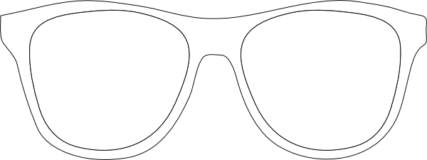

- Music– 18th May-29th May 2020 (Complete Over 2 Weeks)
- Follow the link https://www.youtube.com/watch?v=qJs3vtKU6Gc, close your eyes and listen to the piece of music all the way through.
- Repeat the above step.
- How would you describe the music? How does the music make you feel? What does the music make you think of? Where might you hear this music? How would you move to this music?(experiment using movement with the music).
- In your hardback/on an A4 sheet draw a picture of something that comes to your mind when you listen to this music.
- Continue to practice a tune a day on your tin whistle.
- P.E.– 18th May-29th May 2020 (Complete Over 2 Weeks)
- Ball Handling Skills
Using a Ball
- Develop and practise ball-handling skills by rolling or throwing a small ball (under arm and over arm) at a target e.g a hoola-hoop or into a box
- Chest passing and bounce passing from a stationary position using a large ball and a small ball with a partner from set positions.
- Overhead pass with a partner. How many passes can you make in 15 seconds?
- Receiving (catching) a pass at various heights (waist, chest, head). How many passes can you make in 15 seconds?
- Chest passing a ball at a wall and catching before the ball bounces.
- Chest passing at the wall with another person. One person passes to the wall and the other person catches the ball without allowing it to bounce and they pass it at the wall and so on.

- Pick a song each week from Just Dance (Youtube) and perfect the moves to go along with it.
- Try doing some exercise with Joe Wicks (The Body Coach) on Youtube.
- Continue with Wellness Wednesday Activities.

