Additional Work to be Completed for Each Class –8th June-12th June 2020
(English, Irish and Maths)
- Some Activities are to be completed over a two week period (see dates).

English, Maths and Irish Activities (8th-12th June 2020)
1st Class | 2nd Class | 3rd Class
English  English Reading –‘Two Little Frogs’-Read Stories ‘Why Zebras have Stripes’ and Rumplestiltskin’, one story every two nights (Mon-Tues, Wed-Thurs)( Reading - Please write in Page Numbers at front of book and Sign!)  - Complete written activities for ‘The Colours of the Rainbow' and Rapunzel'). Don’t Worry about Colouring!  - Poem for June 'Sand by John Foster'-Stick Poem into Copy and Practice for Each Night. Do a picture to accompany your Poem.  Maths  - Complete Week 35 in Mental Maths Book  - Mathemagic -  - Please revise below!  - Time (1st Class) - On a clock,the minute hand is longer than the hour hand. When the minute hand is at 12,it is something o' clock. The shorter hour hand tells us which o' clock it is. If you have a clock at home - practice showing different o'clock times, by moving the hands to the correct position.  - Half Past - When a clock shows half past the longer minute hand is at six. The shorter hour hand tells which half past it is. The hour hand will be half way past the number of the time shown. (e.g if it is half way past the nine - it is half past nine. Also practice showing half past times on a clock!  - Days of the Week-Time can also be counted in days. Can you say the days of the week? Practice naming the first, second, third ....last day of the week. What days are at the weekend? What do you do on certain days?  - Time, Year,Months, Seasons  - Discuss a year having four seasons. Name them. How many months in each season? Name them. How many seasons in a year? How many months in a year? Name the first month, the second month......, the last month.  - Ordering Time  Events happen in a certain order-Something happens first, next and last.  - Complete Pages 133, 134 and 135  - Money (1st Class) - If possible get a 1c, 2c, 5c, 10c and 20c coin to show your child what they look like, compare the colour, size and designs on the different coins and point out the different numbers on the coins. Ask them to explain how they could tell the difference between the different coins.  - Complete Pages 110, 111, 112, 113 and 114  - If your child needs help to count up, allow them to use something concrete(e.g some pasta pieces or a ruler as a number line).  Irish  - Abair Liom C – Aonad 2 – An Zú  - p10-p11- Click on the Link on website to practice the vocabulary.  - P12(A)- Listen to voice recorded message sent by email to complete this activity.  - p13 (c)- Draw what you think happens next.  - p14 (D)- Cad a fheiceann Síofra?=What does Síofra see?, Feiceann Síofra eilifint.=Síofra sees and elephant. This is an oral language activity-take turns with your child, one person asks the question for the different characters and the other person answers. Listen to voice recorded message for an example.  - p15 (E)-Colour the pictures that start with the letter 'm'- . Listen to voice recorded message in order to complete this activity.  - Watch some Cúla-TG4 | - English Reading – Choose a book you have at home and read for about 15 minutes each day.  - Can you remember what an acrostic poem is? If not find out! I want you to brainstorm as many summer words as you can think of on a piece of paper, then choose one of the templates. You can print a template or create one of your own. Create one acrostic poem entitled 'Summer'/'Sunny'/  'Sunshine'or  'Holiday'. I would love to see a picture of your poem or even a video of you reciting it.  Templates  - Poem for June 'Sand by John Foster'-Stick Poem into Copy and Practice for Each Night. Do a picture to accompany your Poem.  Maths  - Complete Week 35 in Mental Maths Book  Mathemagic -  - Money(2nd Class) - If possible get a 1c, 2c, 5c, 10c, 20c, 50c, €1 and €2 coin to show your child what they look like, compare the colour, size and designs on the different coins and point out the different numbers on the coins. Ask them to explain how they could tell the difference between the different coins.  - p75 - All you need to do here is write what coin is needed to make the total of €1  - p76(Q2)-Figure out what coins make €1-use the number of coins shown.  - p77-Find out the change given from 50c by adding the missing numbers in the blue squares together.  e.g.1. 2c+10c=12c  - p140-Use the same method as above but this time you have €1 to spend. Remember €1=100c.  - p143(Q1-Q2)-Change cent to euro and cent using the € sign and euro and cent to cent using the c for cent.  Remember to that €1=100c  - p146-Find out the change given from €2 by adding the missing numbers in the blue squares together.  e.g.1. 5c+20c+20c=45c  Irish  - Abair Liom D – Aonad 28 – Súil Siar 4  - p138-(A)I have the words below. See can you pick the correct word to put under the correct picture.  *(glasraí/fidil/spád/siosúr/  dréimire/sábh).  (B)-Rinne = Did/Ní dhearna=did not/Tá cabhair uaim=I need help./Níl cabhair uaim=I don't need help. -Use these words to fill in the spaces.  - p139-(C)Spot the differences, (D)Unscramble the sentences.  - Practice Reading Sheet for June  - Watch some Cúla-TG4 | - English Reading – Choose a book you have at home and read for about 15 minutes each day.  - Can you remember what an acrostic poem is? If not find out! I want you to brainstorm as many summer words as you can think of on a piece of paper, then choose one of the templates. You can print a template or create one of your own. Create one acrostic poem entitled 'Summer'/  'Sunny'/  'Sunshine'or  'Holiday'. I would love to see a picture of your poem or even a video of you reciting it.  Templates  - Poem for June 'Sand by John Foster'-Stick Poem into Copy and Practice for Each Night. Do a picture to accompany your Poem.  Maths  - Complete Week 35 in Mental Maths Book  Mathemagic -  - Please revise below!  - Time (3rd Class) - On a clock,the minute hand is longer than the hour hand. When the minute hand is at 12,it is something o' clock. The shorter hour hand tells us which o' clock it is. If you have a clock at home - practice showing different o'clock times, by moving the hands to the correct position.  - Half Past - When a clock shows half past the longer minute hand is at six. The shorter hour hand tells which half past it is. The hour hand will be half way past the number of the time shown. (e.g if it is half way past the nine - it is half past nine. Also practice showing half past times on a clock!  - Quarter Past - When a clock shows a quarter past the longer minute hand is at three. The shorter hour hand tells which a quarter past it is. The hour hand will be a quarter way past the number of the time shown. (e.g if it is a quarter way past the nine - it is a quarter past nine. Also practice showing a quarter past times on a clock!  - Quarter To - When a clock shows a quarter to the longer minute hand is at nine. The shorter hour hand tells which a quarter to it is. The hour hand will be a quarter away from the number of the time shown. (e.g if it is a quarter away from the nine - it is a quarter to nine. Also practice showing a quarter to times on a clock!  - p152-You only need to write the answers - don't worry about the questions.  - p154-Answer the questions on the calendar. You only need to write the answers - don't worry about the questions.  - Money(3rd Class) - If possible get a 1c, 2c, 5c, 10c, 20c, 50c, €1 and €2 coin to show your child what they look like, compare the colour, size and designs on the different coins and point out the different numbers on the coins. Ask them to explain how they could tell the difference between the different coins.  - p139(Q2 and Q4)-Change the euro to cent and the cent to euro -exactly as shown in the book.  - p140(Q1 and Q2)-complete exactly as shown in the book. Remember if there are no euro values you put a zero in the euro space.  - p141(Q2)-Use the menu to find the cost of the different menus and write the name of the person who had the meal that cost most/least.  - Use the Method Below - I have done Ben's Menu so you can continue from there.  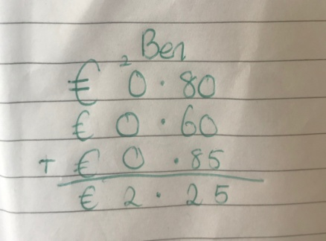  - p142(Q3)-Crack the Code. These are subtraction sums. So use the method for subtraction.  *Remember the Method for W, R and H is as follows.  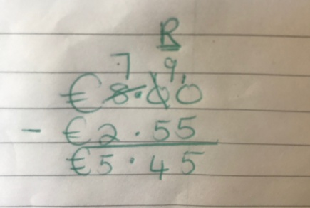  1. Look at the last 0 in the units place. You can't take 5 away from it, so you look to your next door neighbour (the tens).  2. The next door neighbour has nothing to give so you look at the 8(hundreds).  3. You take 1 of the hundreds and put it in front of the 0 in the tens place. You know have ten tens. Remember you only have 7 now in the hundreds space.  4. You can now take one of these tens and you have 9 left. You change the ten to ten units in the units place.  5. Now work out your sum.  Irish  - Abair Liom D – Aonad 19 - An Bhainis  - p158 -(A) -. Listen to voice recorded message in order practice reading the story. Answer the questions.  - p159 -(B) Listen to voice recorded message in order practice reading the comhrá. Answer the questions. (C) Pick one word from each box to complete each sentence. For example, 1. Nach bhfuil an aimsir seo go dona?=Isn't this weather terrible. go hálainn=lovely/go maith=good/go hiontach=wonderful/go huafásach=awful  - p160 -(D) Complete the sentences. (E) Complete the times -the clocks and words will help you.  - p161-(F) Use the correct form of the verb to complete the sentences for example, 1.Bhí an bhainis ar siúl in ollphuball.  - The bottom part=An raibh tú? Where you?/Bhí mé. I was./ Ní raibh mé. I was not.  An ndearna tú? Did you make?/Rinne mé. I made./Ní dhearna mé. I didn't make.  An ndeachaigh tú? Did you go?/Chuaigh mé. I went./Ní dheachaigh mé. I didn't go.  1=Bhí mé ag ceolchoirm riamh.  - Practice Reading Sheet for June  - Watch some Cúla-TG4
- 1st June-12th June 2020 (Complete Over 2 Weeks)
- S.P.H.E. – (Safety and Protection - Personal Safety)
Water Safety
- Click on Link www.teachpaws.ie and this will bring you to the Irish Water Safety Website.
- Scroll down and click on this image.
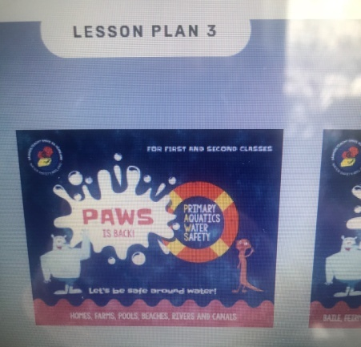 - Water Safety Booklet
- Read the Water Safety Booklet aloud.
- After reading each page, see can you recall two safety tips for each one.
- Go back to the home page or reuse the link above and click on the image that looks like the picture below….

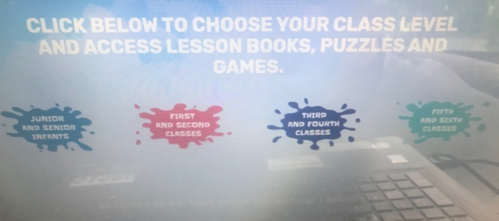-
CLICK ON RED (First and Second Class)
- Click on each Life Buoy and Complete the online activities surrounding water safety (What’s the Word?, Say it Right!, Yes or No!, Click the Correct Picture, Does this Float?, Is it Safe?, Finish the Word).
- In your hardback write the title ‘Water Safety Tips' and write down 5 water safety tips and illustrate them. Divide your page as shown below.
- Design a poster with a slogan to show one of your safety tips.
Water Safety Tips
1. | 2.
3. | 4.
5.

- 1st June-12th June 2020 (Complete Over 2 Weeks)
Geography – (Human Environments -My County)- Copy or print the templates and do in your Hardback Copy!
- Before you commence this activity, get a piece of paper and brainstorm as many things as you can that you already know about your County.
- Then click on the link below and complete the templates and put them into your hardback copy. Alternatively copy the information from the templates into your copy in order to complete them-if no printer is available.

Click on the PDF File to View the Templates

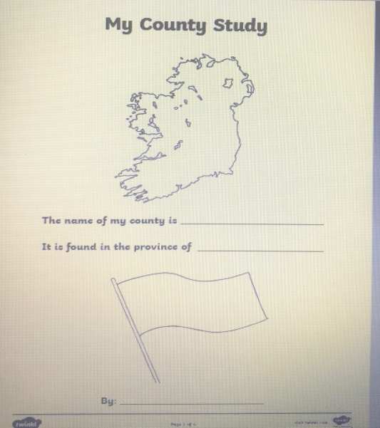Template 1

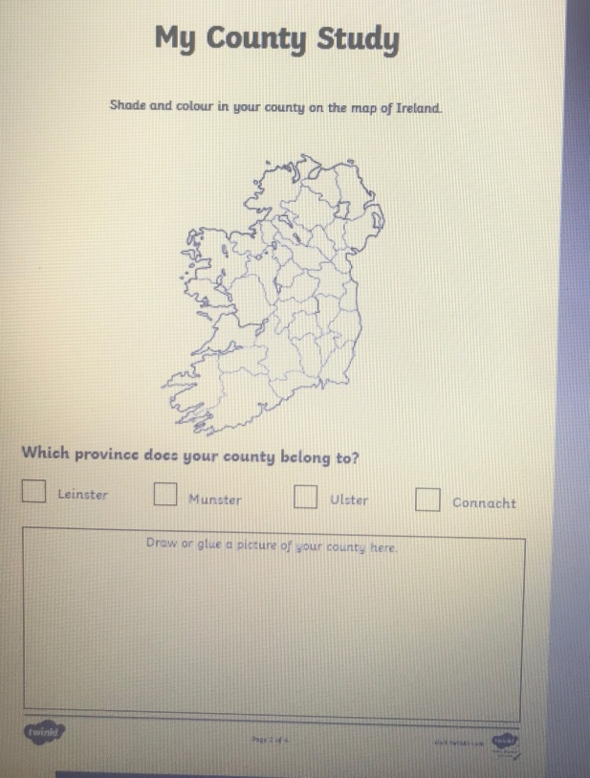 Template 2

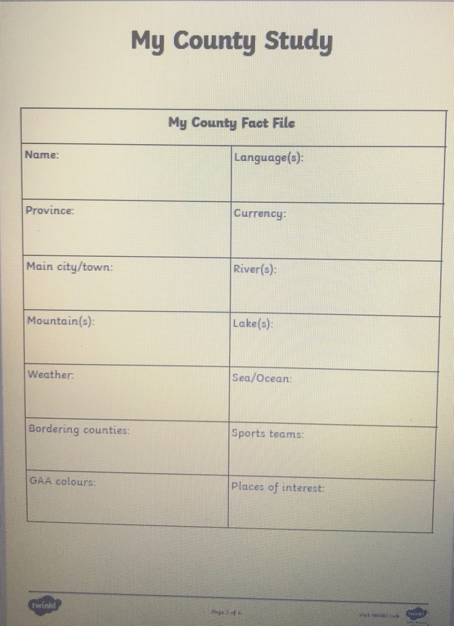Template 3

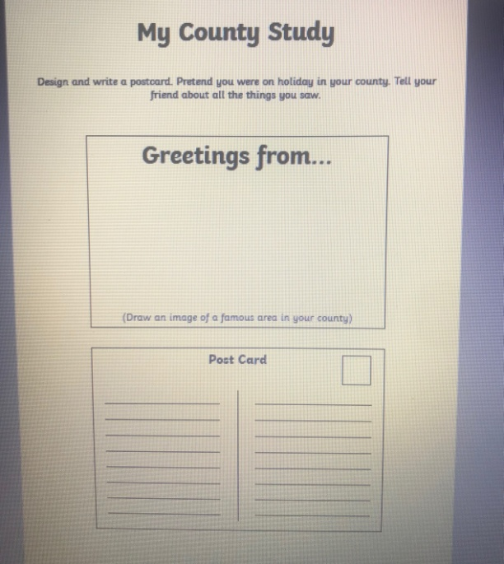Template 4

- Religion – 1st June-12th June 2020 (Complete Over 2 Weeks)
- Say a morning prayer and evening prayer each day and night.
The Importance of Water in the Church.

- What do you call the special water that is used in the church? It is known as Holy water and it is water that has been blessed by a member of the clergy for example, a priest.
- Holy Water is used in the church for many reasons and occasions.
- Every time we bless ourselves with Holy water, we are reminded of the Holy water poured on our heads at our Baptism (when we were welcomed into God's family).
- Holy water cleanses away our sins and also protects us.
- Talk about and research other times we use Holy water in the church. Complete a page in your religion copy as follows and illustrate your examples.
Water is Important in the Church
Holy water is used at....... | Holy water is used at.......
Holy water is used at....... | Holy water is used at.......
*Practice blessing yourself with Holy water and say your favourite prayer.

- Art – Paint and Colour, Construction -1st June-12th June 2020 (Complete Over 2 Weeks)
Under the Sea.
- Discuss things you think you might find under the sea. What type of creatures, plants, objects may you see there? They can be real or imaginary!
- You can paint/construct/or both what you imagine you would find under the sea.
- Here are some pictures for inspiration but use your imagination to create your Under the Sea themed art.
- Send me a picture of your art work.
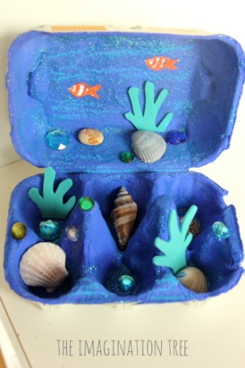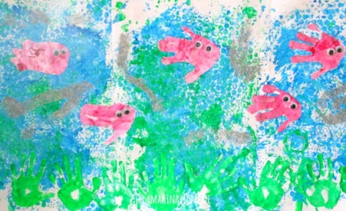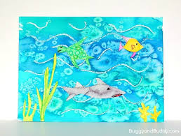

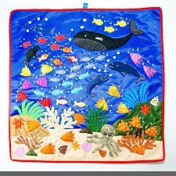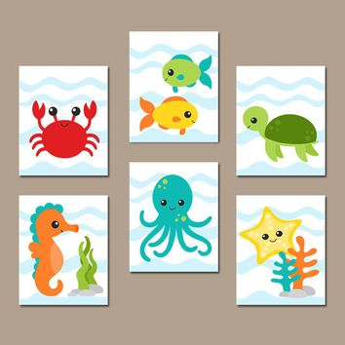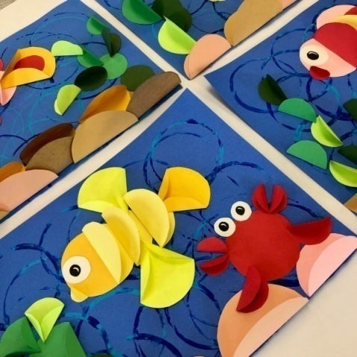

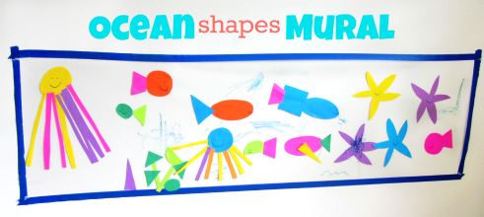

- Music (Listening and Responding, Performing)– 1st June-12th June 2020 (Complete Over 2 Weeks)
- Rock the Boat. This is one for all the family! Watch the video and try out the 'Rock the Boat Song.
- https://www.youtube.com/watch?v=Kq00G0T-JQw.
- Challenge - use other modes of transport in the song in place of a boat - for example, Rock the Bicycle, Rock the Car, Rock the Skateboard and imagine doing the actions for moving this mode of transport.
- Continue to practice a tune a day on your tin whistle.
- P.E.– 1st June-12th June 2020 (Complete Over 2 Weeks)

- Gymnastics
- Move into free space using various travelling movements (walk, hop, skip, jump). Move forwards, backwards and side wards, using these movements. Explore different pathways (straight, curved and zigzag). Explore different speeds and heights (e.g. walk high (e.g. high knees and arms, and low feet and arms).
- Explore different ways of travelling on their feet (hopping, skipping, marching, twirling). Change the speed and the height of the movements.
- Travelling on hands and feet, explore different ways of travelling on these body parts, forwards and backwards. Can you do it with tummy facing, facing away from the ceiling. Create a sequence. Travel on two hands and two feet, one and and two feet and vice versa.
- Balancing on large body parts(bottom, front, side, back and shoulders). Holding each balance for a count of 3. Can you move from one balance to another and hold for 3?
- Balancing on small body parts, one hand, one foot, two hands, one foot, two knees and one hand, two hands and two feet, two knees and two elbows. Holding each balance for a count of 3. Can you move from one balance to another and hold for 3?
- Jumping –basic jumps -2 feet to 2 feet, 2 feet to one foot, 1 foot and hop to other foot, 1 foot to two feet (jump), create sequence of jumps. How many jumps does it take you to travel a set distance?

- Pick a song each week from Just Dance (Youtube) and perfect the moves to go along with it.
- Try doing some exercise with Joe Wicks (The Body Coach) on Youtube.
- Continue with Wellness Wednesday Activities.

