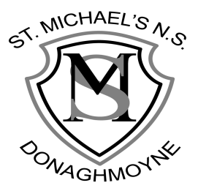

St Michael’s NS,
Donaghmoyne, Telephone: 042 9662284
Carrickmacross, Email: stmichaelsnsdonaghmoyne@gmail.com
Co. Monaghan, Website: www.stmichaelsns.ie
A81 EA37.

Principal: Ms F Whelan
Vice Principal: Mrs R Campbell

Annual Admission Notice
in respect of admissions to the 2023/2024 school year

Admission Policy and Application Form
A copy of the school’s Admission Policy and the Application Form for Admission for the 2023/2024 school year is available as follows: –
To download at: www.stmichaelsns.ie
On request: By emailing stmichaelsnsdonaghmoyne@gmail.com
On request: By writing to
St Michael’s National School,
Donaghmoyne,
Carrickmacross,
Co Monaghan
A81EA37.

Part 1 - Admissions to the 2023/2024 school year
Application and Decision Dates for admission to 2023/2024
The following are the dates applicable for admission to Junior Infants:

The school will commence accepting applications for admission on | Nov 7th 2022
The school shall cease accepting applications for admission on | March 1st 2023
The date by which applicants will be notified of the decision on their application is | March 12th 2022
The period within which applicants must confirm acceptance of an offer of admission is | Two Weeks
Failure to accept an offer within the prescribed period mentioned above may result in the offer being withdrawn.

Note: the school will consider and issue decisions on late applications in accordance with the school’s admission policy.

Number of places being made available in 2023/2024
The number of places being made available in junior infants | 20

