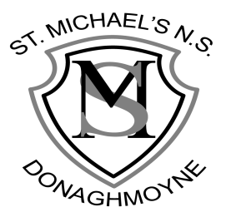

St Michael’s NS,
Donaghmoyne, Telephone: 042 9662284
Carrickmacross, Email: stmichaelsnsdonaghmoyne@gmail.com
Co. Monaghan, Website: www.stmichaelsns.ie
A81 EA37.

Principal: Ms F Whelan
Vice Principal: Mrs R Campbell

